Andrew Botsford
Andrew.botsford@inpex.co.jp
Andrew James Botsford (E5912101) B873 TMA01
June 2024
TMA01
External Analysis and capabilities of inpex europe ltd
Open University B873 Effective Strategic Management in Business and the Public Sector

Contents

Executive Summary 2
Introduction 3
Task 1: External Business Environment 3
Macro-Environmental Assessment 3
Political Considerations 4
Economic Considerations 4
Social and Cultural Considerations 4
Technological Considerations 5
Environmental Considerations 5
Legal Considerations 5
Evaluation of Five Industrial Forces 6
New Entrants 6
Industry Competitors 6
Supplier Power 7
Buyer Power 7
Threat of Substitutes 7
Key Strategic Issues in the External Environment 7
Task 2: Internal Resources and Capabilities 9
Resource Audit 9
Resources 10
Human Resources 11
Capabilities 12
Resource and Strategy Development Recommendations 12
References 15
Task 3: Participation in the Tutor group forum 17

Executive Summary
This report evaluates the external and internal business environment of INPEX Europe Limited (IEL), a renewable energy company based in the UK primarily focussed on offshore wind.
The external business environment of offshore wind in the UK is considered at a macro level within a PESTEL (Political, Economic, Social, Technological, Environmental and Legal) framework. The text describes key considerations in relation to these factors and how they relate to potential opportunities and threats to IEL. A particular opportunity is provided by the politically driven need to decarbonise energy systems, whilst a particular threat to business development is imposed by a shortage of trained workforce.
An industry focussed consideration of the external environment is presented in the five industrial forces model identified by Porter (1979). Offshore wind demand is increasing and has competitive credentials in comparison to substitutes. External threats from existing competitors and new entrants, with linked increases in supply chain costs, present key strategic issues within the external business environment.
An IEL resource audit separates tangible, intangible, and human resources, and outlines key capabilities of the organisation. The primary and support activities as defined by Porter (1985) are distinguished. These resources and capabilities are considered in terms of how they provide competitive advantage using the VRIO framework of Barney (1997). Whilst IEL has strong financial resources and access to existing wind power projects, it is understaffed in comparison to selected peer organisations.
When considering the threat from competitors and new entrants the recruitment of new employees is a key urgent recommendation. IEL can use its robust financial position and business contacts to help source and incentivise new recruits. To de-risk cost uncertainty linked to supplier bargaining power it is recommended that IEL pursues opportunities to acquire one or more supply chain companies utilising our robust financial position and business contacts.

Introduction
INPEX Europe Limited (IEL) was established in 2021 and is the European branch of INPEX Corporation, an energy company with headquarters in Tokyo, Japan. IEL’s activities include support for several business activities within the parent company including renewable power production, hydrocarbon exploration and production, carbon capture and storage, hydrogen production, and trading. The primary activity of IEL is overseeing operation and maintenance of its offshore wind assets in the UK and the Netherlands, whilst exploring new opportunities with a focus on innovation.

Task 1: External Business Environment

Macro-Environmental Assessment
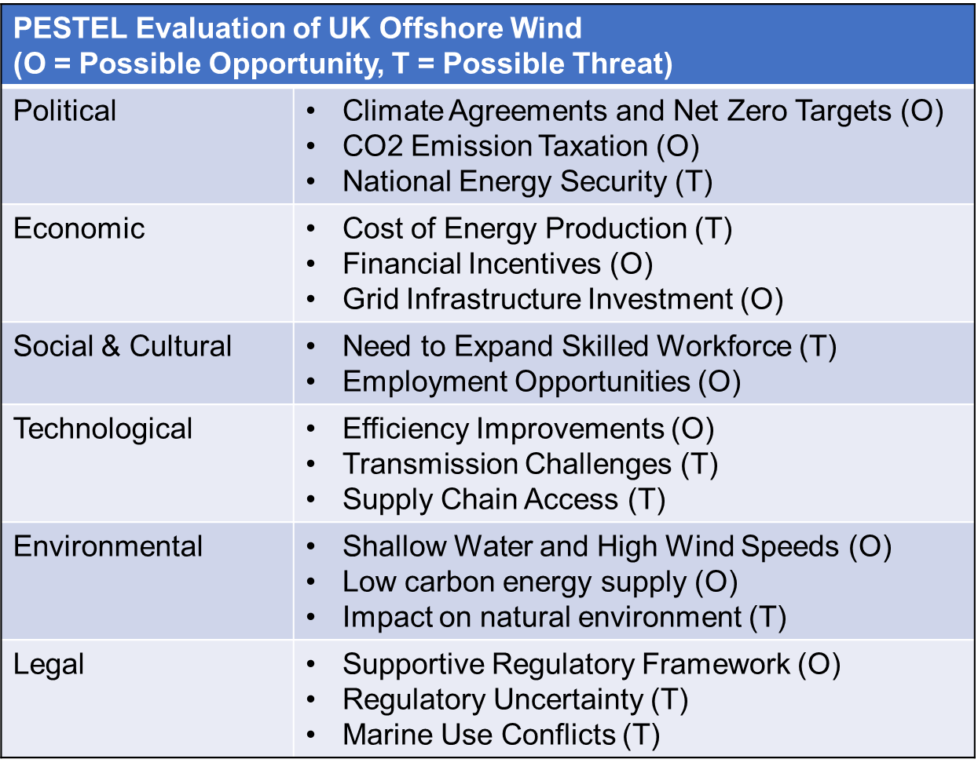
Figure 1: A summary of the macro-environment of UK Offshore Wind Development considered using the PESTEL framework.
Figure 1 provides a summary of the key macro environmental factors influencing the offshore wind industry in the UK today within a PESTEL (Political, Economic, Social, Technological, Environmental and Legal) framework. This systematic approach prompts consideration of the overarching external factors that may influence the business, but as its scope is effectively endless the usefulness of the analysis is constrained by time and knowledge of the analyser.

Political Considerations
The UK has a legal commitment to achieve net zero carbon dioxide emissions across the economy by 2050 (UK Government, 2019). This commitment ensures all governments (past and future) are obliged to encourage development of low emission energy sources and offshore wind is a leading candidate. This favourable political environment presents an opportunity to organisations active in the industry.
Carbon dioxide emission taxation is becoming more widespread. This further increases the appeal of utilising low emission energy sources such as offshore wind and provides increased confidence in the market opportunity.
Recent global political events including wars in the Ukraine and Middle East have increased concern for national energy security. This can act as an opportunity in that it may drive increased focus on developing indigenous energy supply such as offshore wind, but also threatens government focus and a shift in subsidies towards more short-term energy options such as fossil fuel developments.

Economic Considerations
The cost of offshore wind has declined in recent years but is often more expensive than unabated fossil fuel usage and nuclear power. The UK government provides financial guarantees to project developers with a minimum price for electricity produced by renewable sources via the Contract for Difference (CFD) scheme. Opportunities to secure these contracts provides greater confidence in realising value when making financial commitments, but competition can be strong. Market driven Power Purchase Agreements (PPAs) are an additional revenue stream.
The Electricity System Operator (ESO) has announced plans to invest in national grid capacity expansion (ESO, 2024). This provides assurance that newly developed offshore wind farms will find a route to market by being able to connect to customers.

Social and Cultural Considerations
The Offshore Wind Industry Council (2023) have outlined how almost 70,000 additional jobs will be needed by 2030, this requires collaboration across industry and government to ensure capable people are available and attracted to the industry. Whilst this presents a significant opportunity for growth within the UK economy it also suggests potential threats to projects due to inability to find staff or excessive wage escalation.

Technological Considerations
Technological advancements improve efficiency and provide scope for larger projects enabling offshore wind to make an even bigger contribution to the energy transition. Whilst expansion of the national grid has been announced (ESO, 2024) technical challenges remain in sourcing raw materials and establishing construction routes. This makes wind power from some areas harder to deliver to customers.
Increases in offshore wind construction will require supply chain growth to meet increased demand. Original Equipment Manufacturers (OEMs) and raw material providers are likely to face challenges meeting project requirements.

Environmental Considerations
The UK has a high volume of natural wind resources including extensive continental shelf with relatively shallow water depths and high average windspeed throughout the region. This opportunity combined with the global benefit of switching to low carbon emission energy sources makes investment in UK offshore wind an attractive proposition.
Establishing offshore wind farms requires an extensive permitting process including baseline surveys and Environmental Impact Assessments (EIAs). Some planned projects have been stopped due to potential impacts on seabird migrations or fishing communities, for example. Environmental factors identified in these assessments could threaten new projects.

Legal Considerations
The UK has well established legal procedures and systems for dealing with disputes, and its civil service provides wide reaching material pre-empting some legal issues which may arise. In general, the legal environment is more predictable than many other jurisdictions. These supportive regulatory conditions enhance the opportunity in the UK.
Offshore locations suitable for wind farm development are also used for activities such as oil and gas production, fishing, shipping, and carbon storage which gives rise to potential operations issues. Despite potential legal challenges, efficient regulation is required to ensure these industries are all able to continue harmoniously.

Evaluation of Five Industrial Forces
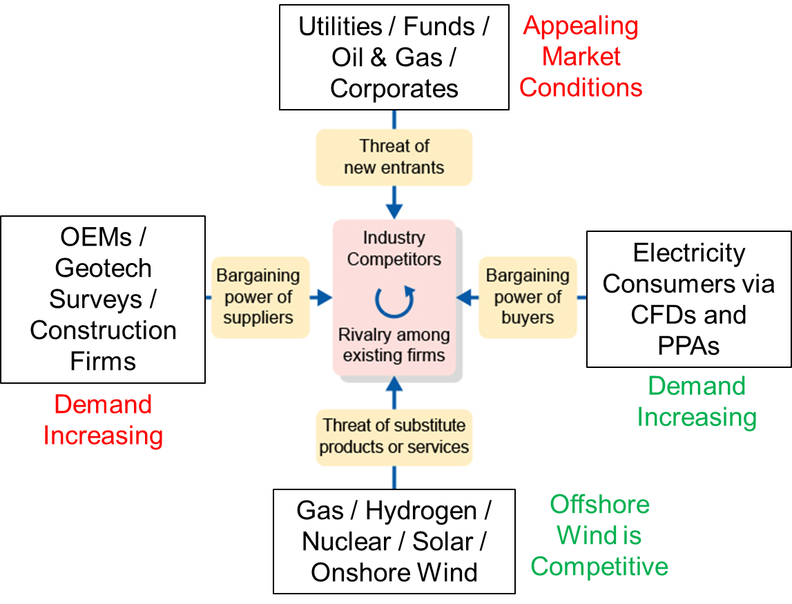
Figure 2: Application of offshore wind considerations to Porter's Five Forces Model. (OEMs- Original Equipment Manufacturers, CFDs- Contracts for Difference, PPAs- Power Purchase Agreements).
Figure 2 provides a visual illustration to consider the five industrial forces identified by Porter (1979). This is a static overview of the current industry position which supports the identification of key strategic issues now, the situation could change gradually or dramatically linking to some of the macro environmental factors outlined previously.

New Entrants
The potential for government support contracts makes the offshore wind industry attractive to new entrants. New entrants into the industry provide competition for seabed leases, drive competition and put pressure on profit margins. The level of funding required for large scale offshore wind projects does however provide an entry barrier to organisations unable to raise capital.

Industry Competitors
Active developers can be broadly assigned to utilities, funds, oil and gas and corporate organisations. Each of these (strategic) groups have similar strengths and objectives within them. Utilities have widespread market knowledge due to their connection to customers but lack global perspective. Funds such as pensions have access to capital at favourable rates and can accept low financial returns for low-risk investments, but the organisations themselves do not have resources capable of achieving the projects. Oil and gas companies have a global perspective and experience managing complex offshore projects, but they face reputational challenges and internal competition from alternative projects with potentially higher financial incentives. Corporate investors looking to vertically integrate their value chain (for example data centres securing access to low carbon electricity) can provide some demand assurance but they lack the skills and experience to develop complex offshore projects.

Supplier Power
Industry growth has increased demand for supplier services. At the same time manufacturing cost increases and a limited number of suppliers (of items such as wind turbines) has increased the difficulty in securing supplies at competitive rates.

Buyer Power
Growing need to decarbonise the energy system provides strong fundamental demand for wind power. Buyers are often willing to commit to long term offtake contracts (Power Purchase Agreements) and the government is confident to guarantee a certain buyer price via CFDs (Contracts for Difference).

Threat of Substitutes
Competition from other energy sources capable of supplying low-cost power to consumers creates threat of substitutes, this includes fossil fuels and other renewables such as solar. Offshore wind is competitive both from a cost and low carbon credential perspective.

Key Strategic Issues in the External Environment
Strategic issues can be thought of as the important questions, topics, and challenges that firms must manage to stay competitive and relevant in the ever-changing business environment (CMOE, 2024). Two key strategic issues for IEL are:
- The threat from competitors and new entrants due to appealing market conditions, and
- The bargaining power of suppliers due to increased demand for their services.
The increasing threat from new entrants and competitors for offshore wind development licenses is a key strategic issue as IEL needs to be able to secure access to licenses to develop projects and enhance our capabilities through experience. New entrants and competition are an uncertainty within the VUCA framework of Bennett and Lemoine (2014) as competitors often have unclear near and long-term objectives making specific challenges to our objectives unpredictable. Competitors can have different costs and return requirements and therefore make different propositions to customers which feed into applications for government support contracts or provide alternative propositions to customers.
The bargaining power of suppliers is another key strategic issue as IEL needs to keep costs low enough to be able to carry out projects and stay competitive. Within the VUCA framework of Bennett and Lemoine (2014) understanding the suppliers bargaining power can be complex, uncertain, and volatile. It can be complex as suppliers of different components manage various factors in their own supplies and value addition processes, and items such as levels of raw materials for turbine construction are often difficult to know. Uncertainty arises from similar issues even when supply pathways are known, for example if several companies need deliveries at similar times this could place strain on the supplier which can have knock on effects on the capability of IEL to deliver projects within planned time frames. Another factor in supplier bargaining power is the volatility caused by raw material pricing such as energy and critical elements.

Task 2: Internal Resources and Capabilities

Resource Audit
Porter (1985) classified primary and support activities within a business. Support activities can provide advantages in effectiveness whereas primary activities are more industry specific. In general, IEL has well developed support activities established through traditional oil and gas business by its parent company. These are relatively easy to transfer across industries whereas primary activities associated with offshore wind need to be developed further in relation to competitors.
The table below outlines key resources and capabilities of IEL, primary activities are highlighted in yellow:
Resources | Capabilities
Tangible
Ownership of Offshore Wind Farms with Long Term Offtake Contracts and Government Revenue Support | Project Management
Robust Financial Position | Financial Management
Established Procedures and Practices | Project Evaluation
Office Buildings and Equipment | Commercial Negotiations
Intangible | Business Administration
INPEX Brand and Industry Reputation | Health and Safety Compliance
Business Relationships (including Governments)
Positive and accepting working culture
Human resources
Technical Skills (eg engineers)
Commercial Skills
Administrative Skills

As outlined by Grant (2010) the resources on the left give rise to organisational capabilities which, when aligned to industry success factors, provide a competitive advantage. An assessment of the competitive advantages provided from these is provided below utilising the VRIO framework devised by Barney (1997). The framework offers a systematic thought process to consider resources but there is personal interpretation involved in its application. For example, whether government relationships are valuable and/or difficult to imitate might depend on the experience of the evaluator and it is difficult to know whether competitors also possess similar relationships.

Resources
Existing wind farm assets are valuable as they provide long-term revenue and understanding of offshore wind projects including technical and commercial issues. There are several companies with many more assets in the UK, as shown in Figure 3. However, these assets are rare in comparison with international peers. Obtaining new wind farm leases and developing projects takes many years and is therefore difficult to imitate. The wind farms are exploited both in terms of revenue generation and capability development.
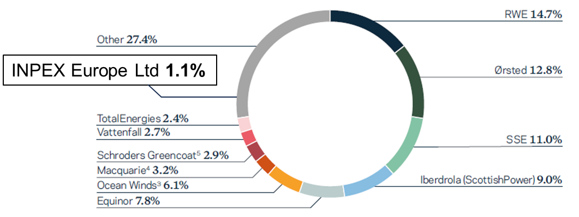
Figure 3: The share of UK offshore wind assets by company in 2023 (The Crown Estate, 2023).
IEL’s robust financial position and ability to meet financial commitments is valuable in UK offshore wind. Many development companies do not have access to similar funding, it is therefore rare and access to finance at these levels is hard to imitate. The robust financial position is exploited to gain sight and positions in projects.
Established procedures and practices (eg HR policies, audit procedures) are valuable and necessary to operate a business. Meeting all regulatory employment requirements and implementing good practice can take time, it is not rare but can take time to imitate for new entrants. They are exploited by facilitating ethical corporate behaviour enabling large scale projects to be managed in a considerate manner, accountable to stakeholders.
Office buildings and equipment are valuable and necessary to carry out everyday activities, however they are not rare or hard to imitate as many businesses possess comparable office facilities. The facilities are exploited by IEL to carry out daily activities.
The INPEX brand and industry reputation is relatively established in Japan, Australia, and SE Asia but has only limited recognition value in Europe. It can be valuable as it provides streamlined access to partners, investors, and relevant stakeholders. Some competitors have less established reputation suggesting it is rare. Carrying out activities aligned with the brand are hard to imitate by others, and INPEX has an association with Japan that is impossible to replicate by other international companies. The reputation is exploited to gain confidence from investors and business partners.
IEL business relationships are valuable as they support new business development and market knowledge as well as access to supply chains and off takers. Business contacts are a factor in the number of new opportunities received and how easily activities can be carried out. In general, these contacts are not rare on their own but collectively they can be useful in navigating current communication channels and are a key factor in business development. Building a network takes time and is hard to imitate. These relationships are partly exploited at present but could be utilised further if a bolder approach in developing projects or acquiring new businesses is applied.
A welcoming culture is valuable in supporting staff well-being (and retention). Aspects of INPEX are unique and embraced by its personnel and emphasised by its stated values (INPEX Corporation, 2024), but as other organisation have similar values these are not rare. Creating a welcoming culture can be imitated, but this must be demonstrated through time. The working culture is exploited by INPEX and demonstrated by the fact it has a relatively low staff turnover (personal experience).

Human Resources
Figure 4 provides a simple view of the status of IEL within the UK offshore wind industry in comparison with three peer companies for which data could be accessed. IEL is an incumbent with low employee numbers in comparison to these peers, as indicated by the employee per MW figure, but this doesn’t include the employees available to IEL through its parent company.
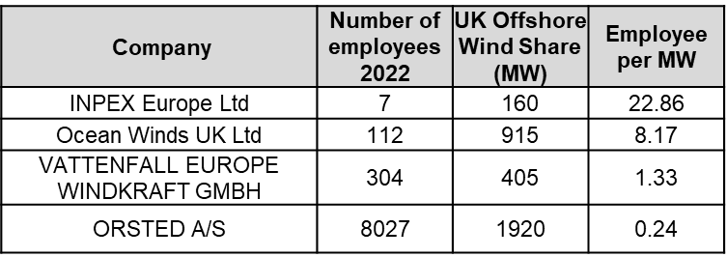
Figure 4: Comparison of IEL with four other UK offshore wind companies active in 2022. Data based on The Crown Estate (2023) and company reports accessed via Orbis Europe.
Administrative skills are essential to the smooth running of the business, they are valuable and exploited by the organisation. Whilst not rare in comparison to technical skills, learning how things are done takes time so they can also be hard to imitate, but less than technical and commercial skills.
Technical skills are highly valuable in supporting the design, construction, operations, and maintenance of offshore facilities. These rare skills require many years of university level training and experience. These skills are hard to imitate by competitors as employing these skilled staff is expensive and difficult to justify without sufficient market access. INPEX exploits technical skills to build knowledge and expertise in executing large scale projects.
Commercial skills are valuable in supporting contract negotiations and identifying growth opportunities. Commercial skills require a high level of training and knowledge and are rare and difficult to imitate. These are exploited to build business relationships and in financial aspects of project development.

Capabilities
Project management capabilities are a valuable ability to capture, process, and act on information from a wide variety of sources and types at a large scale. This capability has been developed on oil and gas projects and is rare and difficult to imitate. Whilst the capability is exploited by the organisation in Asia, IEL are not a leading project developer in the European region.
Access to Japanese government funds and assurance is valuable for investor confidence and can provide capital at competitive interest rates. This is rare among offshore wind participants and would be hard to imitate for non-state linked organisations. IEL exploits access to funds to add new business resources.

Resource and Strategy Development Recommendations
The data in Figure 4 suggests IEL is significantly under resourced in terms of employee numbers in comparison with these peers. When considered with the key strategic issue of the threat from competitors and new entrants the recruitment of new employees is a key recommendation. IEL can use its robust financial position and business contacts to help source and incentivise new recruits. Technical skills provide an important differentiator so new recruitment must focus on improving this capability to access new projects and rise above competition. In addition, IEL should continue to nurture its positive and accepting working culture to ensure employee exits are minimised in face of competition.
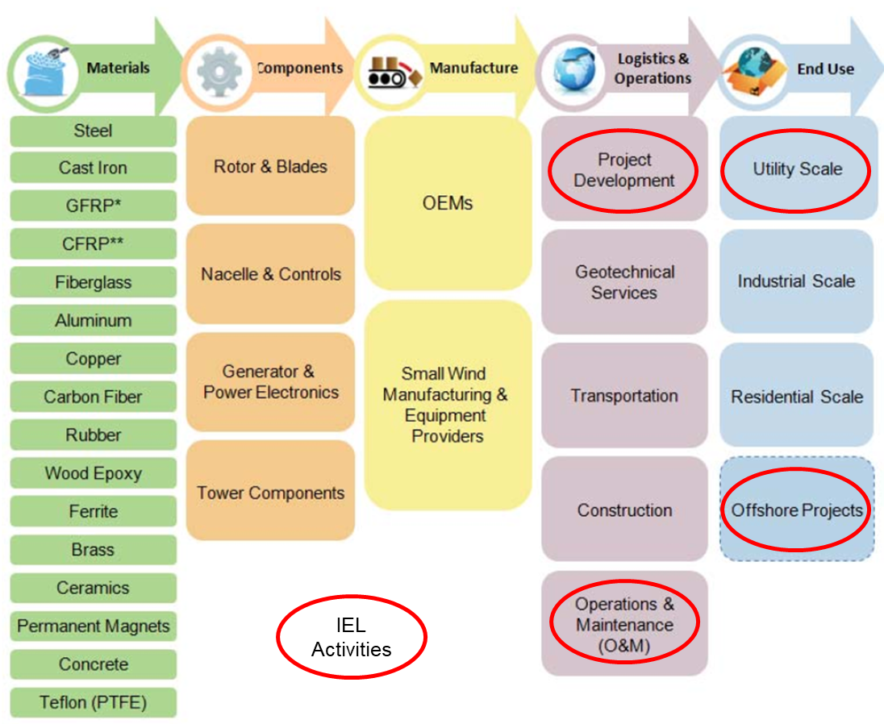
Figure 5: A typical wind power value chain with major activities of INPEX Europe Limited outlined (adapted from Ayee et al, 2009).
The functions of IEL within the offshore wind value chain include project development and operations and maintenance. The position of these within the wind power value chain are shown in Figure 5. Organisations in the Manufacture and Logistics & Operations columns are suppliers currently enjoying increased bargaining power due to service demand (Figure 2), driving cost increases recognised as a key external strategic issue to IEL.
To de-risk cost uncertainty linked to supplier bargaining power it is recommended that IEL pursues opportunities to acquire one or more supply chain companies utilising our robust financial position and business contacts. Whilst some suppliers (such as OEMs) might be beyond the reach of IEL due to cost, vertical integration within the supply chain will enable greater control in relevant areas. An additional factor is that acquiring companies will add human resources to address the issue highlighted above, allowing us to boost our competitiveness with industry peers through growth in collective knowledge.
Whilst the overall motivation for expanding into renewables can be considered strategic fit (adapting INPEX Corporation to an external low carbon future), the recommended approach for IEL is considered strategic stretch in the concept proposed by Hamel and Prahalad (1993) as it extends our existing capabilities. The advantage of stretch is that it focuses on our improvement and lies within our control. Whilst there could be a risk of exposure from over stretch, current market conditions are favourable and long-term political considerations suggest a relatively stable situation will continue. The key existing capability of INPEX is large scale project management developed in oil and gas operations. To effectively transfer this capability to the offshore wind industry new skills must be added. IEL are lucky to have access to capital at low interest rates and must take advantage straight away.

References
Ayee, G., Lowe, M. and Gereffi, G., 2009. Wind Power: generating electricity and employment. Center on Globalization Governance & Competitiveness, Duke University: Durham, NC, USA.
Barney, J B. (1997) Gaining and sustaining competitive advantage. Reading, Mass.: Addison-Wesley.
Bennett, N. and Lemoine, G.J. (2014). “What a difference a word makes: understanding threats to performance in a VUCA world.” Business Horizons, Vol. 57, No. 3, pp. 311–317.
CMOE (Center for Management and Organization Effectiveness), 2024. “What are strategic issues in strategic planning?”. Available from: https://cmoe.com/glossary/strategy-issues/#:~:text=What%20are%20strategic%20issues%20in,colors%2C%20shapes%2C%20and%20sizes. (Accessed: 10/6/2024)
ESO, 2024. ESO publishes “Beyond 2030” – a £58bn investment plan in the future of Britain’s energy system. Available from: https://www.nationalgrideso.com/news/eso-publishes-beyond-2030-ps58bn-investment-plan-future-britains-energy-system#:~:text=ESO%20publishes%20investment%20plan%20for,in%20Great%20Britain%20by%202035 (Accessed: 5/6/2024)
Grant, R.M. (2010) Contemporary strategy analysis. 7th edn. Chichester: John Wiley & Sons.
Hamel, G. and Prahalad, C.K. (1993) ‘Strategy as stretch and leverage’, Harvard Business Review, 71(2), pp.75–84.
INPEX Corporation, 2022. INPEX Vision @2022: Long-term Strategy and Medium-term Business Plan. Available from: https://www.inpex.co.jp/english/company/pdf/inpex_vision_2022.pdf (Accessed: 4/6/2024)
INPEX Corporation, 2023. INPEX Acquires Shares in UK Offshore Wind Power Generation Company. Available from: https://www.inpex.co.jp/english/news/assets/pdf/20230302_b.pdf (Accessed: 7/6/2024)
INPEX Corporation, 2024. INPEX Values. Available from: https://www.inpex.co.jp/english/company/value.html (Accessed: 18/6/2024)
Offshore Wind Industry Council, 2023. Over 100,000 offshore wind jobs by 2030 with decisive action on skills. Available from https://www.owic.org.uk/news/over-100%2C000-offshore-wind-jobs-by-2030-with-decisive-action-on-skills (Accessed: 5/6/2024)
Porter, M.E. (1979) 'How competitive forces shape strategy', Harvard Business Review, 57(2), pp. 137–145.
Porter, M.E. (1985), Competitive advantage: Creating and sustaining superior performance. New York: FreePress.
The Crown Estate, 2023. UK Offshore Wind Report 2023. Available from: https://www.thecrownestate.co.uk/our-business/marine/offshore-wind-report-2023 (Accessed: 4/6/2024)
UK Government, 2019. UK becomes first major economy to pass net zero emissions law. Available from: https://www.gov.uk/government/statistical-data-sets/monthly-domestic-energy-price-stastics (Accessed: 5/6/2024)

Task 3: Participation in the Tutor group forum
Posts
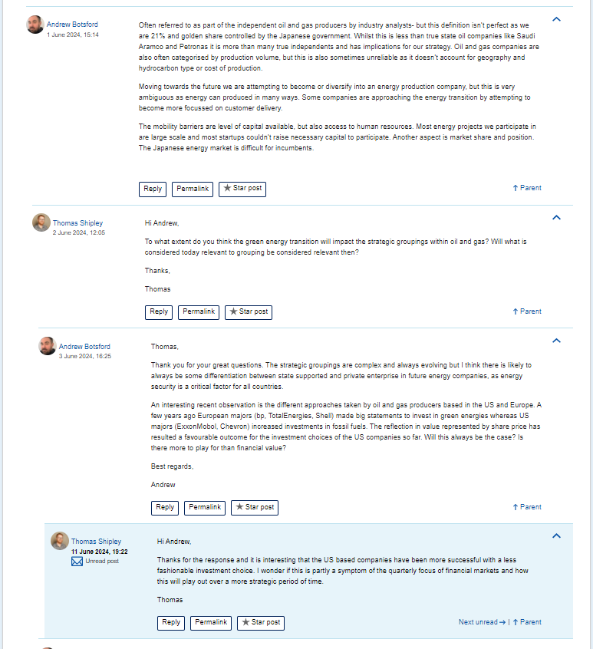
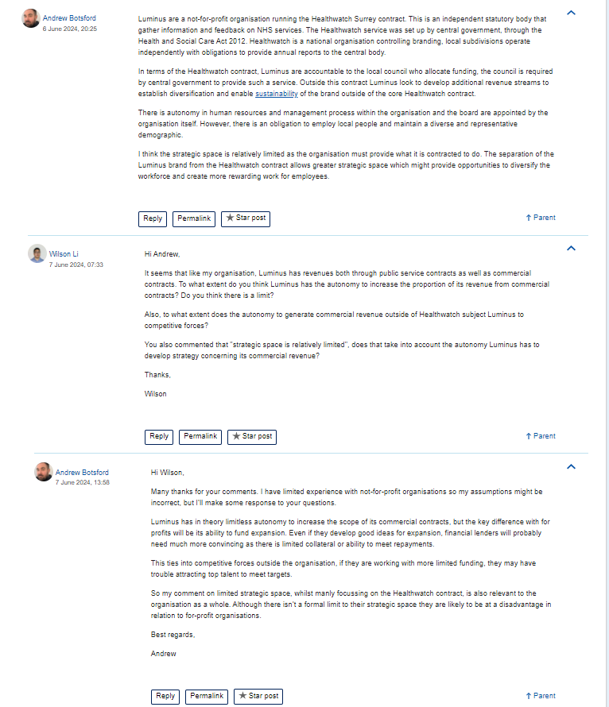
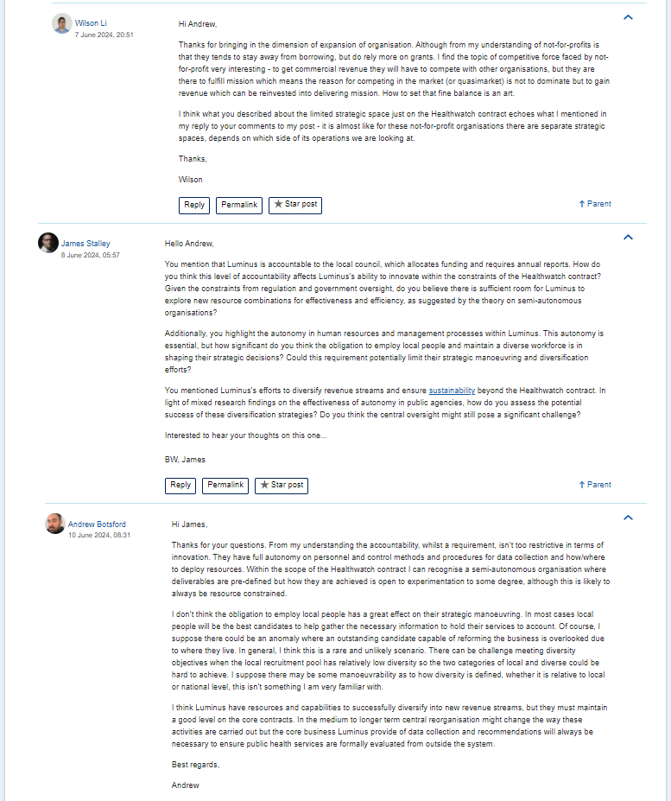

Comments
